#### Integration of photosynthetic efficiency rhythmic profile with multi-omic data

Fv/Fm rhythmic profiles are integrated with the proteomics and transcriptomics data of the PSII, PSI and chlorophyll binding proteins (ANEXO con las proteinas consideradas o tabla aquí?). During summer photoperiod, those photosynthesis proteins are maintained at the same abundance levels during the light hours. However, the Fv/Fm levels are not equally maintained during the light hours as proteins do. Instead, the optimal photosynthetic efficiency (higher Fv/Fm) is observed when transcription of photosynthetic genes is taking place (Fig. 37-A). It suggests that, during summer photoperiod, there is not a significant temporal offset between gene-protein-physiological responses. Genes are translated as soon as they are transcribed and photosynthetic efficiency increase as proteins are *de-novo* synthesized. During winter photoperiod, as it was mentioned in Chapter 3, the gene-protein offset become larger. Gene expression and de-novo synthesis of proteins are not taking place simultaneously as they apparently do during summer photoperiod. In agreement, maximum photosynthetic efficiency takes place few hours after the maximum gene expression level (Fig. 37-B). In addition, rhythmic profiles with 12h period (2 peaks every 24h) under winter photoperiod are not only observed in Fv/Fm, but also in the transcriptomic response. Photosynthesis genes present two peaks of expression per day, as many other genes do under winter photoperiod (Fig. 26-A). In this case, one of the expression peaks takes place during the first part of the morning, increasing photosynthetic efficiency during the maximum irradiance hours. Whereas, the second peak of expression takes place during the night, preparing the photosynthetic machinery with anticipation to sunrise, suggesting It suggest that photosynthesis machinery anticipation to photoperiod is transcriptionally regulated in *Ostreococcus tauri* and, probably, since early in the green lineage.

Only a reduced number of proteins with a clear role on photosynthesis were included in the previous results in order to correctly correlate their profiles. However, Photosynthesis is a process where a huge amount of proteins are involved and different metabolic pathways strongly depend on its execution. Photosynthesis is executed by an electron transport chain that consist of three big protein complexes (Photosystem II, cytochrome b6f, Photosystem I) that use electrons obtained from water to generate NADPH. The protons accumulated inside the lumen during this transport are used by the ATPsinthase to produce ATP. NADPH and ATP are needed to fix CO2 and generate carbon compounds in the Calvin cycle that can be accumulated as a reservoir of starch. In higher plants, the circadian clock participates in the coordination of different physiological processes like

photosynthesis, carbon fixation and starch biosynthesis (de los Reyes, Romero-Campero, Teresa Ruiz, et al., 2017; Farré & Weise, 2012; Graf et al., 2010)⁠. Multi-omics data presented in this thesis allow generate a complete picture of how these processes respond and anticipate to seasonal and diurnal cycles in *Ostreococcus tauri*.

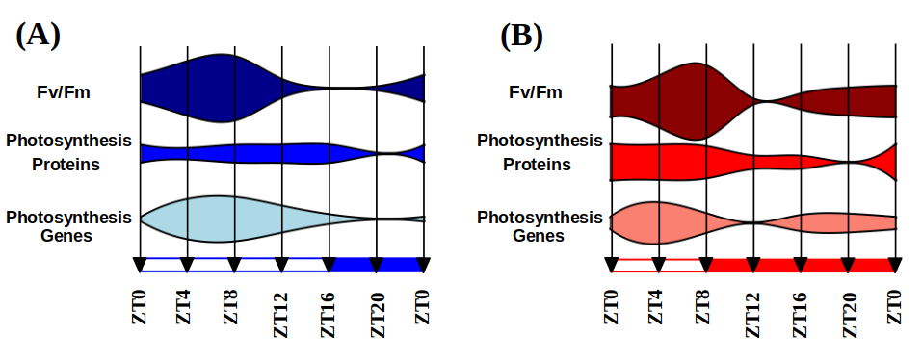Figure 37. **Integration of Fv/Fm oscillations with multi-omic data.** Fv/Fm measurements are integrated with multi-omic data from proteins and genes related with photosynthetic efficiency under summer (A) and winter (B) photoperiod.

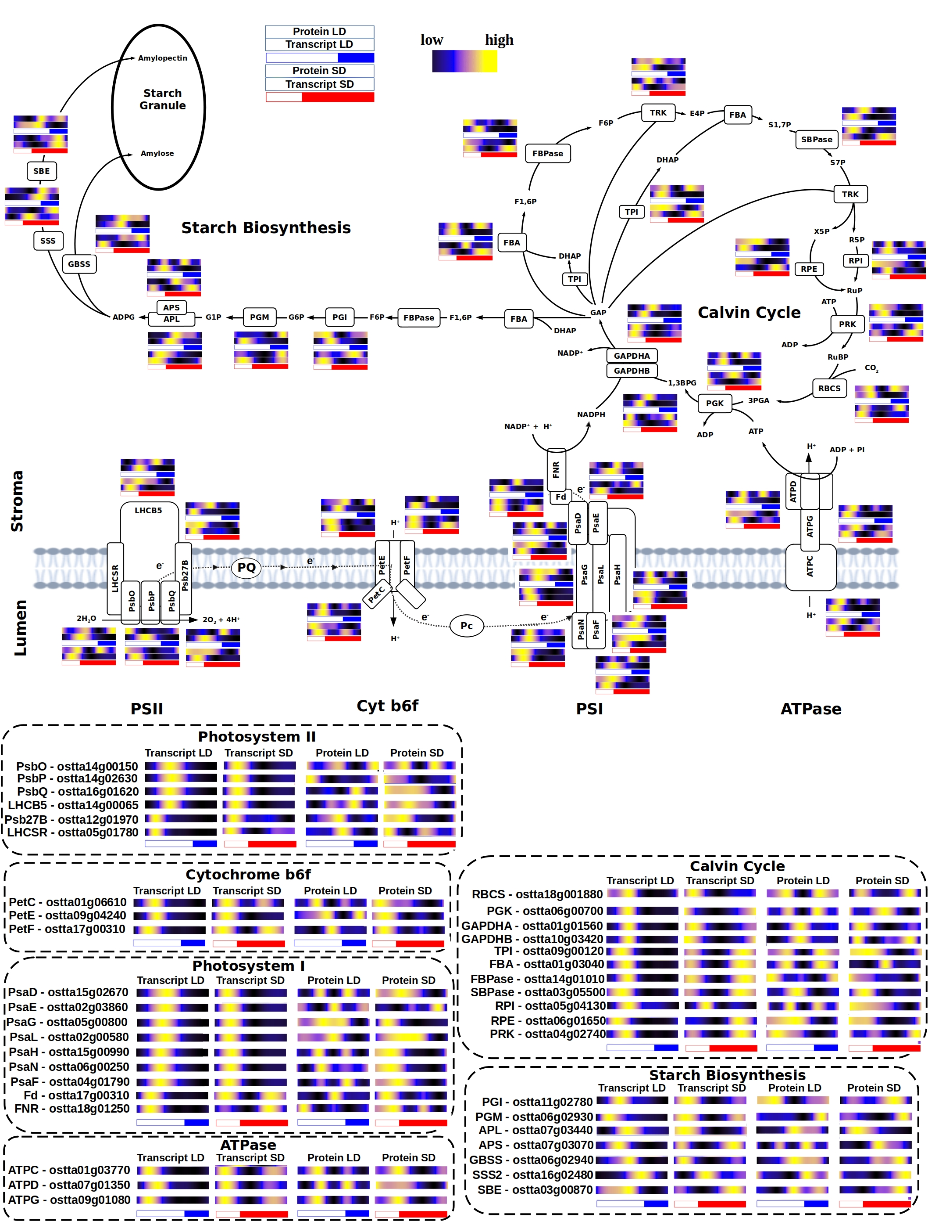

Figure 38. **Integration of multi-omic data of genes and proteins involved in photosynthesis, Calvin cycle and starch biosynthesis.**

Genes involved photosynthetic electron transport chain and Calvin cycle are uniformly expressed early in the morning during both summer and winter photoperiod. The expression of those genes early in the morning seems to be conserved independently of the photoperiod, since it has been also observed in *Ostreococcus* under 12h of light and 12h of dark (Monnier et al., 2010)⁠. However, the already mentioned rhythmic profiles with 2 peaks of expression per day are described by numerous genes involved in both processes during winter photoperiod (Fig. 38). The anticipation to the short light period during winter photoperiod is not only reflected on photosynthesis efficiency (Fig. 36-37). Instead, it is found systematically in the complete metabolic interaction of both processes.

Protein abundance rhythmic profiles with 12h period are observed under summer photoperiod. This phenomenon has been previously observed in RuBisCO small subunit (RBCS) in plants (CITA pedir a fran). Multi-omics integration of our results shows that this phenomenon is present systematically in the Calvin cycle enzymes, as well as some proteins from the photosynthetic electron transport chain. Also, these 12h period profiles are not transcriptomically regulated, since its encoding transcripts describe one peak of expression per day. The mRNA rhythmic profiles of some enzymes from the Calvin cycle are in agreement with previously published data in plants (Pilgrim & McClung, 1993)⁠, so it suggest that a strong post-translation regulatory mechanism is causing this 12h period profile in proteins involved in photosynthesis during long photoperiods in both microalgae and plants.

#### Integration of starch content diel oscillations with multi-omic data

There exists an influx of carbon compounds obtained from the Calvin cycle to starch. The accumulation and degradation of starch have been described to be circadian regulated, since a periodic oscillation of its content is observed in photosynthetic organisms as *Chlamydomonas* and *Arabidopsis,* as well as a rhythmic gene expression profile of the enzymes involved in the process (Flis et al., 2019; Ral et al., 2006; Sulpice et al., 2014)⁠. *Chlamydomonas* reaches its maximum starch content few hours after sunset (Ral et al., 2006)⁠, while *Arabidopsis* plants reach it exactly at sunset (Feugier & Satake, 2013)⁠. In both organisms, starch starts to accumulate during the light hours, until amylases (AMY) are activated and its degradation starts. Starch content is a result of a controlled balance between its degradation (where AMY is involved) and its synthesis (where APL is involved). Starch content in *Ostreococcus tauri* under diurnal cycles is also rhythmic with a 24h period (Fig. 39), reaching its maximum starch content at the high irradiance hours under both summer and winter photoperiods.In *Ostreococcus tauri*, AMY (ostta10g00260) protein abundance increase right after the high irradiance hours, coinciding with the beginning of starch degradation. Whereas, APL (ostta07g03440) protein abundance seems to increase in order to counter the degradation of starch during the night and avoid carbon starvation (Fig. 39-B).

In plants, starch degradation during winter photoperiods has been described to be executed more slowly than during summer photoperiod (Feugier & Satake, 2013; Sulpice et al., 2014)⁠, which is in agreement with the results presented in this thesis for Ostreococcus (Fig. 39-A). In addition, both APL and AMY protein abundance profiles are strongly coincident with their gene expression profile with a ~4h offset, showing that starch synthesis-degradation balance is possibly transcriptomically regulated. These results suggest that there is not a conserved starch content temporal program throughout the green lineage as it has been observed with other biological processes in this thesis. However, a strong transcriptomic circadian regulation and seasonal adaptation seems to be conserved.

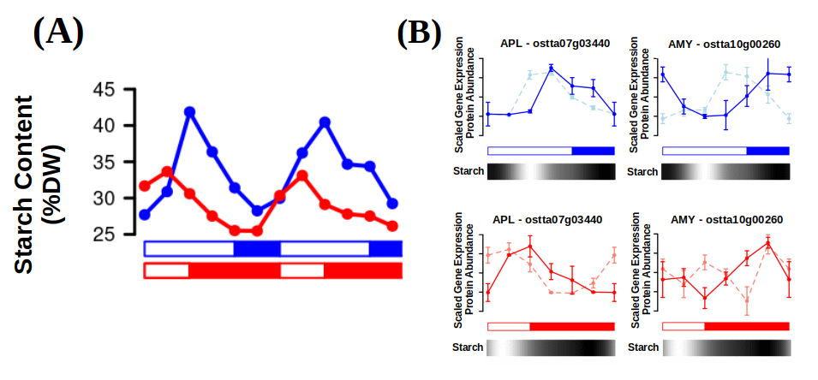Figure 39. **Starch content periodic oscillations (A). Gene expression (¿Línea continua?) an protein abundance (¿Línea discuontinua?) of the main enzymes involved in starch synthesis (APL) and degradation(AMY) (B).**

### More metabolic pathways of *Ostreococcus tauri* show periodic oscillations under diurnal and seasonal cycles

#### Carotenoids biosynthesis in Ostreococcus tauri under diurnal and seasonal cycles

Carotenoid are a group of isoprenoid pigments that are present in several organisms including microalgae and plants. Some of these pigments are associated with light harvesting complexes and play a crucial role in photosynthesis by absorbing light energy and transferring it to reaction centers. Carotenoids also act as antioxidants, protecting the organism from damage caused by excess light or environmental stress (García-Plazaola et al., 2017; Sun et al., 2022)⁠. Carotenoids are produced and accumulated at the most appropriate time to perform their functions. In fact, expression of genes involved in carotenoid biosynthesis are regulated by the circadian clock in plants and algae (Covington et al., 2008; García-Plazaola et al., 2017; Pan et al., 2009; T. H. Sun et al., 2010; Zhang et al., 2022)⁠.

In addition to their role in photosynthesis, carotenoids also have significant nutritional value for humans. Some carotenoids, such as β-carotene, can be converted into vitamin A, which is essential for vision and the immune system. Other carotenoids as astaxanthin have also been shown to have potential health benefits, reducing the risk of certain types of cancer and heart disease (Eggersdorfer & Wyss, 2018)⁠.

Industrial production of carotenoids involves the large-scale cultivation of photosynthetic microorganisms such as algae. In the last two decades, numerous research groups have been studying growth conditions, microalgae metabolism and optimizing photobioreactors design in order to maximize carotenoids production while minimizing costs (Del Campo et al., 2004; Hoys et al., 2021; Sierra et al., 2008)⁠. Since they are cultivated outdoors, understanding how carotenoids biosynthesis oscillates under diurnal and seasonal cycles is crucial to ensure the maximum carotenoids content at harvesting time, as well as to find possible gene and proteins targets. However, the possible influence of the circadian clock on carotenoids production optimization still remains unknown due to a lack of research of the topic. This thesis work aims to contribute to elucidate the circadian regulatory mechanism of carotenoids biosynthesis in order to enhance their industrial production.

##### Integration of multi-omics data with oscillations described by carotenoids content in *Ostreococcus tauri* under diurnal and seasonal cycles

*Ostreocccus tauri* is rich in widely distributed carotenoids like violaxanthin, antheraxanthin or zeaxanthin. Carotenoids specific of Mamiellophyceae like micromonal, uriolide or prasinoxanthin are also found in this prasinophyte, being prasinoxanthin the most abundant (Egeland et al., 1995; Guyon et al., 2018; Six et al., 2009)⁠. Its genome presents genes encoding for the Methylerythritol 4-phosphate (MEP) pathway (Derelle et al., 2006; L. Zhao et al., 2013)⁠, which derives pyruvate to the production of geranyl pyrophosphate (GPP), the main carotenoid precursor. The carotenogenesis pathway starts in the phytoene synthase (PSY). From lycopene, the pathway has two branches: β-branch, including the xantophylls cycle; and α-branch, including the main antenna carotenoids in prasinophyte which biosynthesis pathways are still unknow (Guyon et al., 2018; Six et al., 2009)⁠.

Carotenoids content during diurnal cycles under both summer and winter photoperiods have been estimated from HPLC profiles, as described in Materials and Methods. The same rhythmicity analysis carried out with the omic data was also achieved to carotenoids content generated from the three consecutive days under light-dark cycles.

Under both summer and winter photoperiods, all carotenoids describe rhythmic abundance profiles with periods of 24h, with a p-value lower than 0.05, with the exception of lutein and violaxanthin, that do not maintain their rhythmicity under winter photoperiod. In general, fluctuations on carotenoids content during winter photoperiod seem to less drastic. (Fig. 40-A).

Oscillating carotenoids content is in agreement with the transcriptomic and proteomic data. The generation of geranyl pyrophosphate is crucial for carotenogenesis, the most of the enzymes involved in MEP pathway present a high protein abundance with anticipation during the night under both summer and winter photoperiod. The enzymes involved in the first steps of the carotenogenesis, from the generation of phytoene with PSY to the fork created by LCYε/β, have their maximum protein abundance during the light hours in summer photoperiod. In winter photoperiod, a clear anticipation can be observed, which describe the maximum abundance of those enzymes just before sunrise. Also, the profiles of the enzymes involved in the xantophylls cycle are in agreement with zeaxanthin and violaxanthin contents. Under summer photoperiod, the maximum protein abundance of violaxanthin de-epoxidase (VDE) match the increasing zeaxanthin content during the light hours, as well as the maximum abundance of zeaxanthin epoxidase (ZEP) match the increasing content of violaxanthin during the dark hours. A similar phenomenon is observed during winter photoperiod, where VDE is present during the light hours and ZEP during the dark hours (Fig. 40-B). However, there is not a significant amount of zeaxanthin being accumulated under winter photoperiods, instead, a high level of violaxanthin without drastic variations is maintained during diurnal cycles (Fig. 40-A). Xantophylls cycle is not enhancing the production of zeaxanthin due to a lack of high irradiance stress during winter photoperiod, as it has been observed in *Ostreococcus* and others prasinophytes under low irradiance (Böhme et al., 2002; Guyon et al., 2018; Six et al., 2009)⁠. In general, the enzymes of the β-branch pathway are coordinated to be present at a specific time of the day. Early in the morning, βCH gene is expressed, sequentially followed by ZEP and VDE in that specific order under both photoperiods (Fig. 40-B). It suggests that β-branch carotenoids are transcriptionally regulated to sequentially achieve their roles at the right time.

Pigment synthesis on the α-branch pathway describes a similar behavior to the one presented in β-branch pathway. *Mantoniella squamata*, accumulates lutein to irradiance stress that convert to prasinoxanthin when the stress condition is over (Böhme et al., 2002)⁠. These results are in agreement with the observed in *Ostreococcus,* with a lack of lutein during winter photoperiod*,* and their accumulation during the light hours in the summer photoperiod followed by the increment of prasinoxanthin content after sunset. Overall, those results suggest that *Ostreococcus tauri* carotenogenesis present the common characteristics of processes regulated by the circadian clock, as being able to adapt to different photoperiods and presenting an anticipation to diurnal cyclic changes. This hypothesis is supported by the results in other prasinophytes, since their carotenoids behavior under irradiance stress seems to be very similar (Böhme et al., 2002; Egeland et al., 1997; Guyon et al., 2018; Six et al., 2009)⁠.

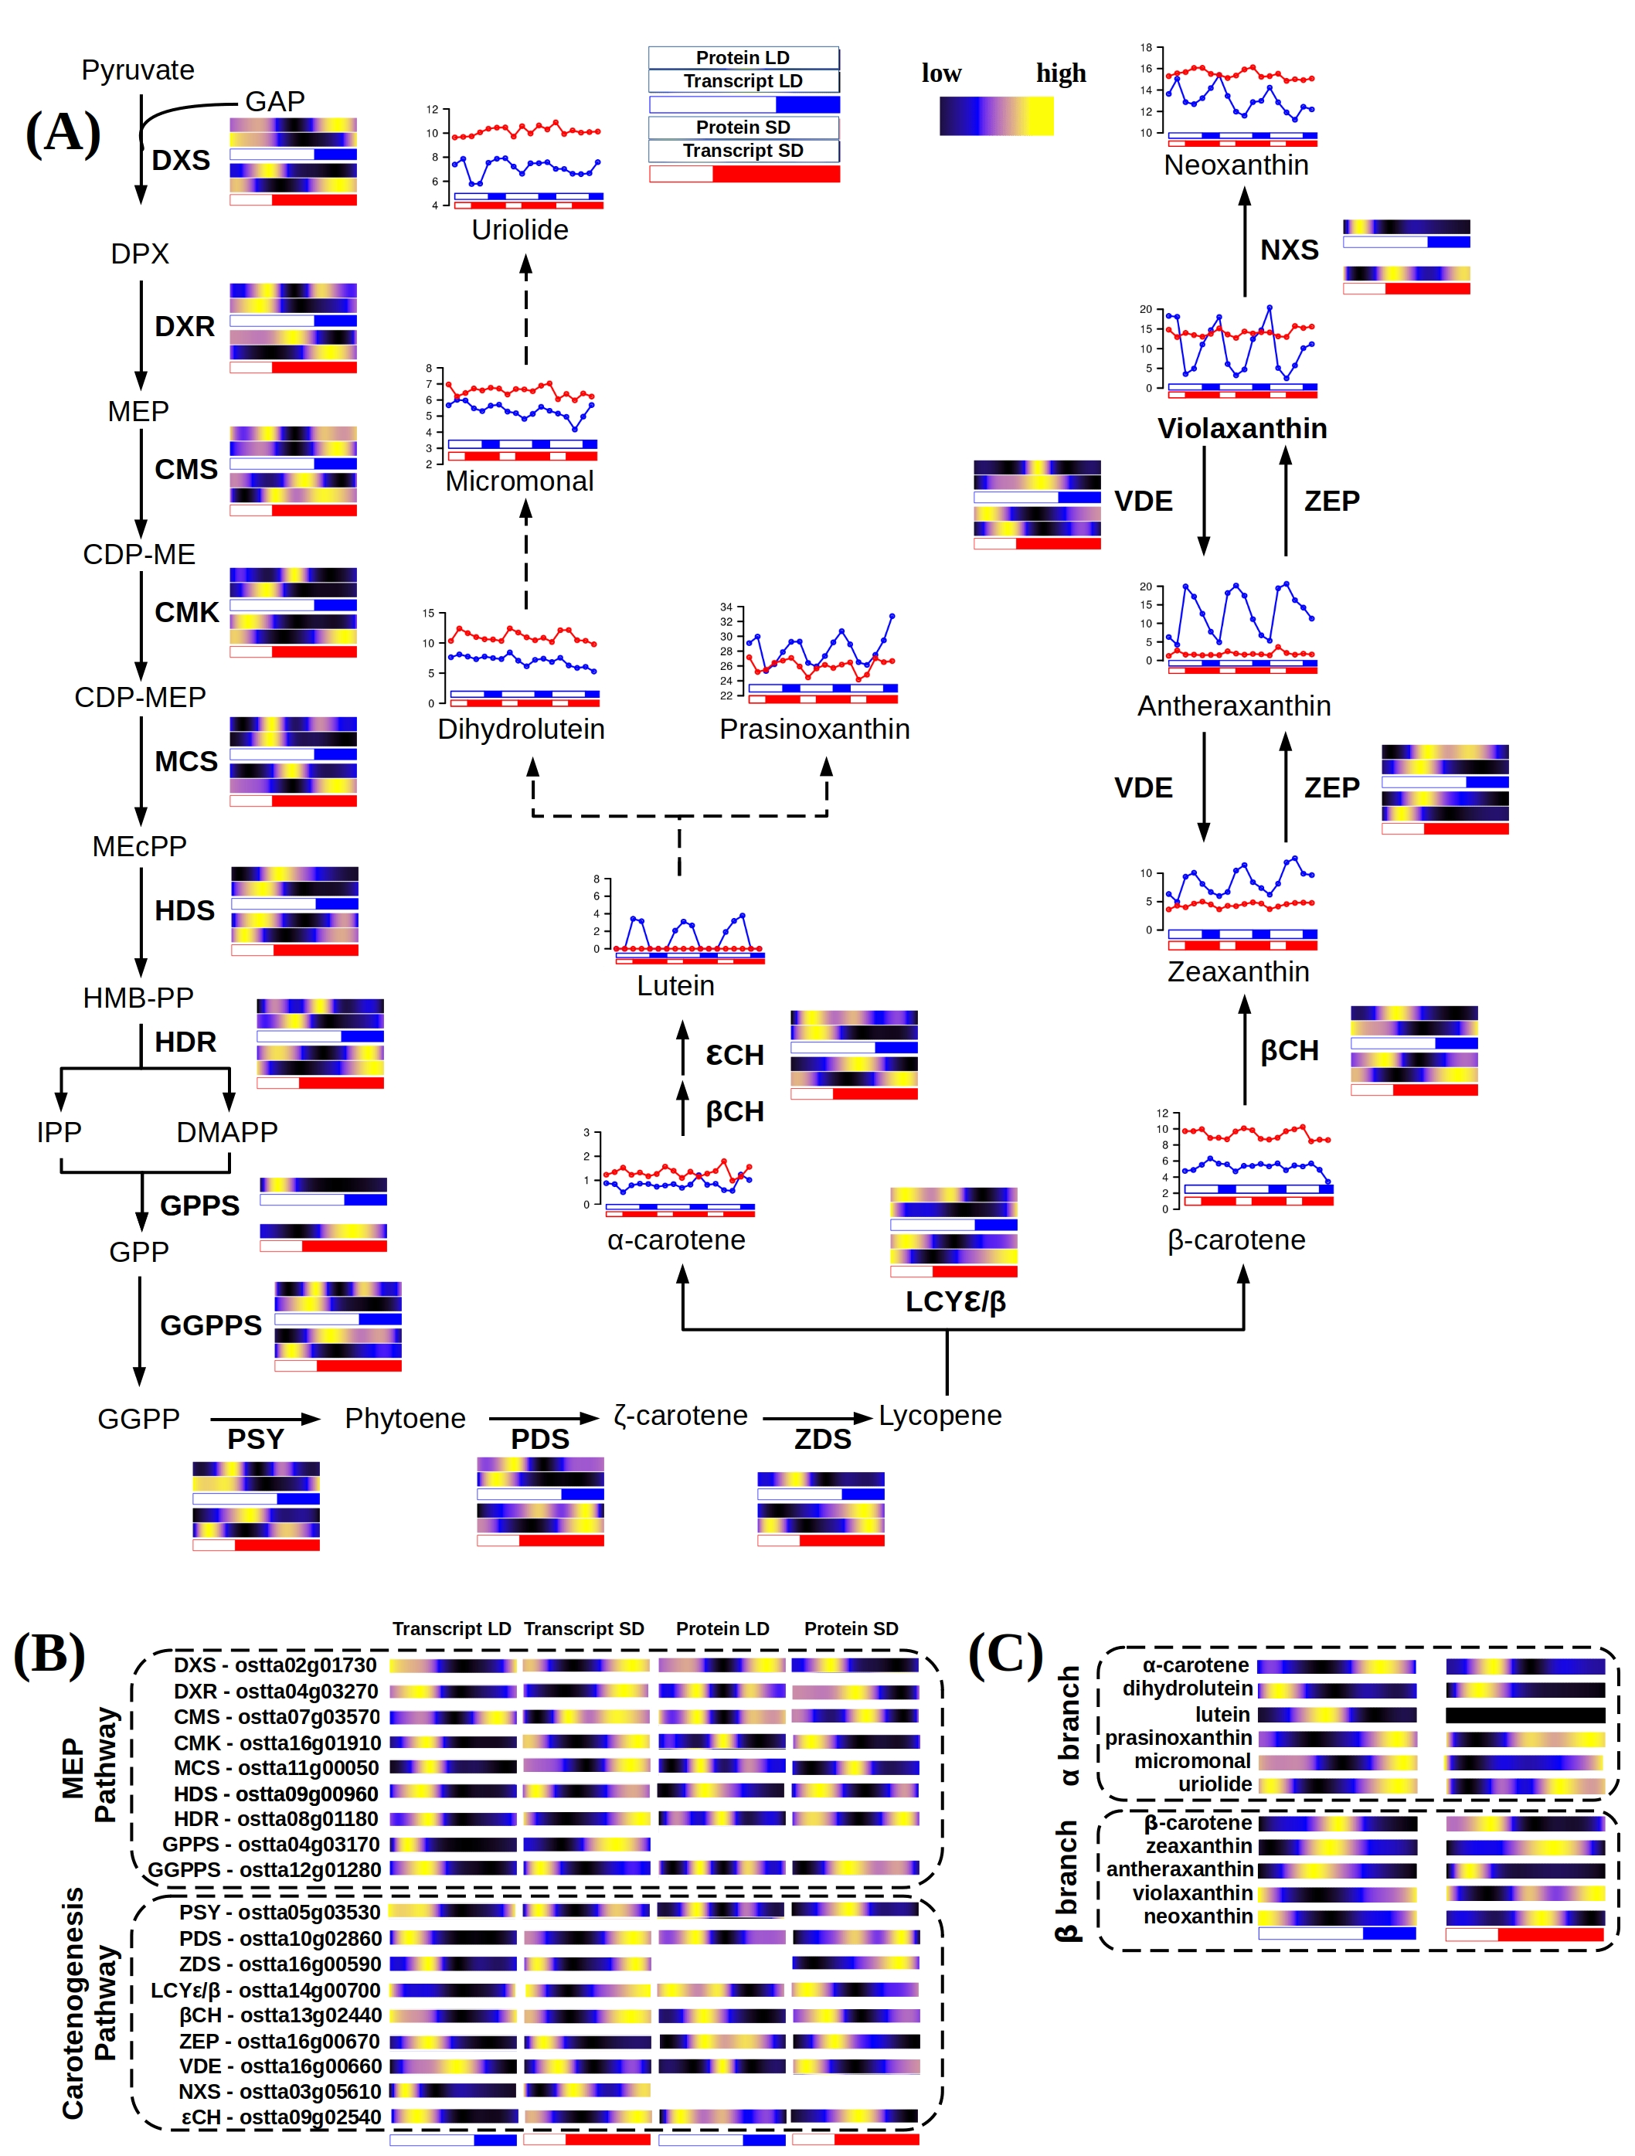Figure 40. **Integration of multi-omics data from the complete carotenoids biosynthesis pathway and carotenoids content of Ostreococcus tauri.** (A) Schematic MEP pathway and carotenogenesis, α-branch biosynthesis pathway according to (Egeland et al., 1997). (B) Organized visualization of multi-omic data from enzymes involved in both MEP and carotenogenesis pathways. (voy a quitar la C, me parece muy repetitivo)

#### Nitrate assimilation under diurnal and seasonal cycles in Ostreococcus tauri

As it has been discussed previously, photosynthetic organisms accumulate reserves during the light hours to support growth at night. Circadian regulation of C reserves as starch content diel oscillations have been already discussed in this work. However, the macroelement Nitrogen is an essential component in biomolecules and itis, in fact, a major limiting nutrient of marine phytoplankton (Barros et al., 2005; Mittag, 2001; Sanz-Luque et al., 2015). . *Ostreococcus* can grow on nitrate, ammonium and urea, and complete sets of genes allowing transport and assimilation of these substrates have been identified in its genome (Blanc-Mathieu et al., 2014; Derelle et al., 2006)⁠. Specifically, in this work, nitrate has been used as nitrogen source. Nitrite reductase (NIR) enzyme of *Ostreococcus* has two additional redox domains that allow this enzyme to use NAD(P)H directly as reducing agent, improving nitrogen assimilation process (Derelle et al., 2006)⁠.

In the previous chapters of this thesis, nitrate assimilation has been identified as one of the biological processes which genes and proteins present significant rhythmic profiles under diurnal cycles, as well as one of the processes with larger offset between gene expression and translation. Here, enzymatic activities of two of the main enzymes involved in nitrate assimilation is presented and integrated with multi-omic data from enzymes involved in the complete pathway.

##### Integration of key enzyme activities from nitrate assimilation pathway with multi-omic data

Although the nitrate assimilation pathway from nitrate to amino acid is relatively simple, its regulation to ensure an optimal nutrient assimilation coupled to changing environmental factors is more complex (Referencia??). Nitrate is first transported into the cell, where nitrate reductase (NR) achieves its reduction to nitrite. Nitrite is transported into the chloroplast, where it is reduced to ammonium by a nitrite reductase (NiR). Finally, ammonium is incorporated to carbon compounds by the glutamine synthetase and glutamate synthase enzymes (GS-GOGAT) (Sanz-Luque et al., 2015)⁠.

Circadian oscillations in expression and activity of the first enzyme of this pathway (NR) have been described in *Arabidopsis* and other crop plants as maize or tomato (Lillo et al., 2001; Lillo & Ruoff, 1989; Tucker et al., 2004; Z. Yang & Midmore, 2005)⁠. In addition, light is apparently an important factor for NR to maintain its rhythmic behavior. Rhythms in NR activity or NR gene expression profiles were shown to persist only in continuous light but not in darkness (Lillo et al., 2001; Lillo & Ruoff, 1989)⁠. These results are in agreement with the transcriptomic data obtained in *O. tauri*, where NR gene expression rhythmic profile is maintained only under light-dark cycles and constant light. This transcriptomic behavior is also present in others enzymes involved in this pathway (Fig. 41).

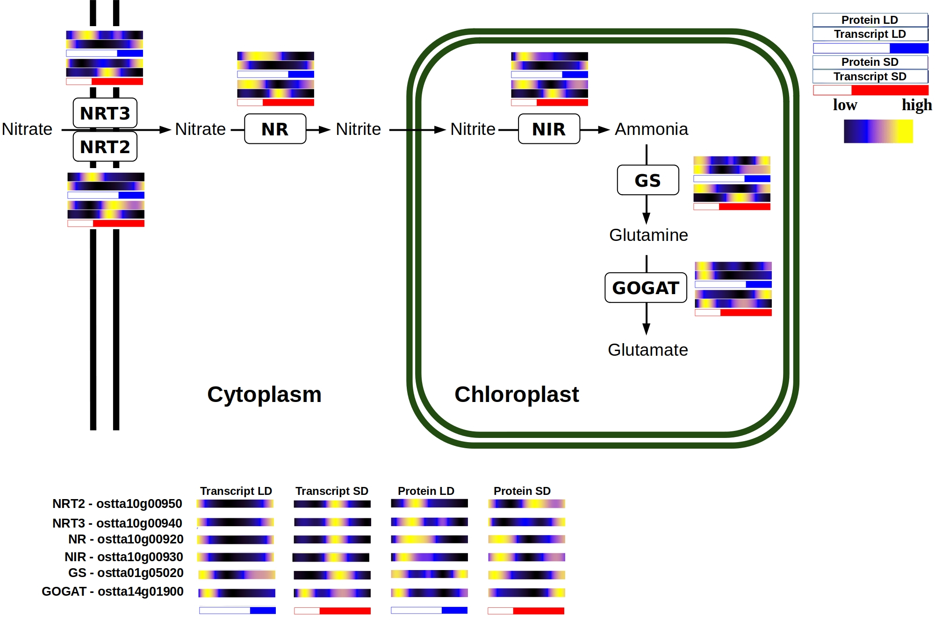Figure 41: **Multi-omics integration of nitrate assimilation pathway.**

Genes involved in this pathway reach their maximum level of expression few hours before sunrise during summer photoperiod, presenting a clear anticipation to the light period. This anticipation become larger in winter photoperiod, where these genes reach their maximum expression in the first part of the night (Fig. 41).

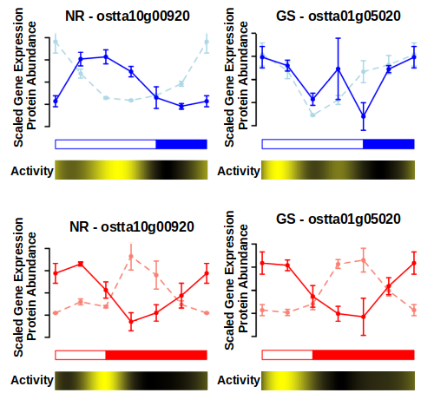Figure 42. **NR and GS rhythmic activity compared with its proteomic and transcriptomic data generated.**

Protein abundance profiles are coincident with gene expression profiles except for the 8-16h offset observed in the enzymes from this pathway (Fig. 42). Enzymatic activities of NR and GS present a significant rhythmic profile with a p-value lower than 0.05 and there is an almost non-existent offset between their protein abundance profile and their activity.

The huge transcriptomic anticipation observed is adjusted by the clock taking in count the large offset between gene expression and translation described by the enzymes involved in this pathway. In fact, although genes are transcribed at different times under winter and summer photoperiod, proteins reach their maximum abundance level around sunrise in both cases (Fig. 41). This is a clear example of how *Ostreococcus* adjust its transcriptional program in order to ensure the presence of proteins at the exact right time, in spite of their specific translation offset.